Chapter 11

Exercise Solutions

Ex 11.1
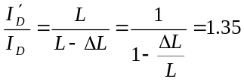
or
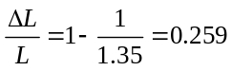

From Example 11.1, we have
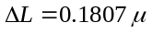m
Then 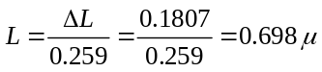m
_______________________________________

Ex 11.2
From Figure 11.10, 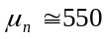cm/V-s
_______________________________________

Ex 11.3
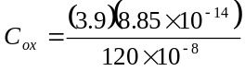
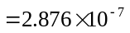F/cm
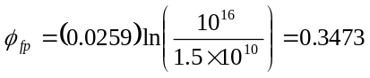V
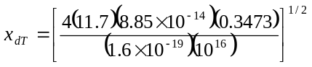
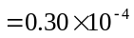cm
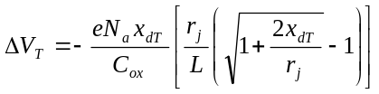
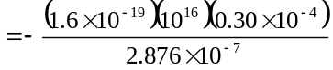
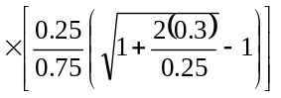
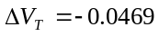V
_______________________________________

Ex 11.4
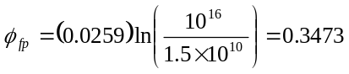V
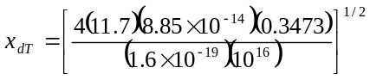
cm
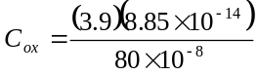
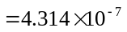F/cm
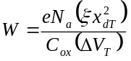
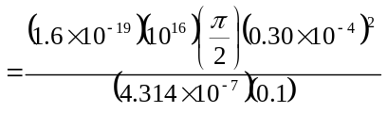
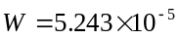cm
or
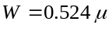m
_______________________________________

Ex 11.5
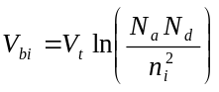
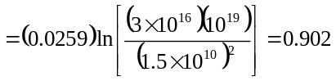V
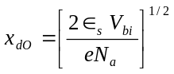
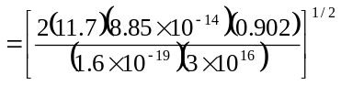
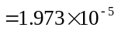cm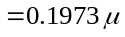m
m
Also
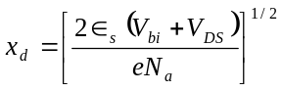
or
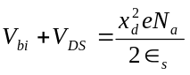

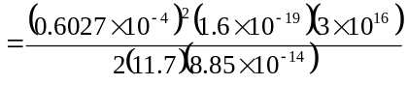
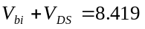V
Then
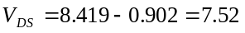V
_______________________________________

Ex 11.6
We find
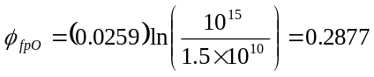V
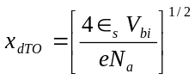
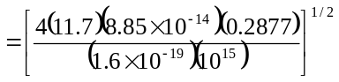
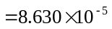cm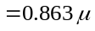m
F/cm
The initial threshold voltage is
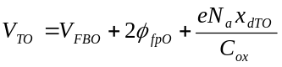
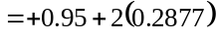
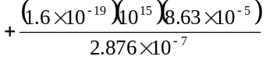
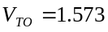V
Now
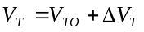
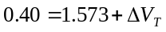
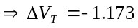V
Negative 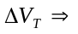implant donor ions
Now
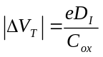
or
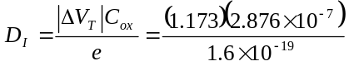
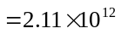cm
_______________________________________

Ex 11.7
- 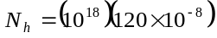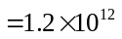cm
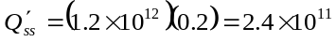cm
F/cm
Then
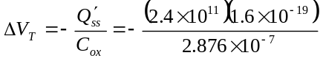
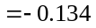V
- 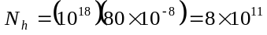cm
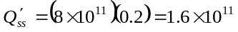cm
F/cm
Then
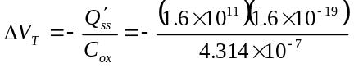
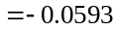V
- Threshold voltage shift decreases when the oxide thickness decreases.
_______________________________________

Test Your Understanding Solutions

TYU 11.1
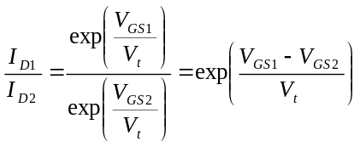
or
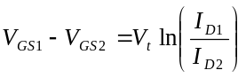
Then
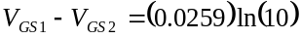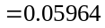V
or 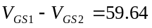mV
_______________________________________

TYU 11.2
- 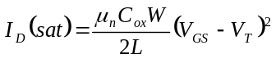
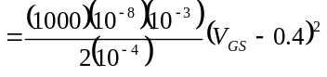
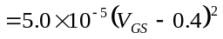A
or 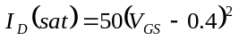A
- 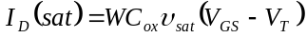
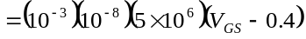
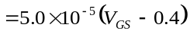A
or 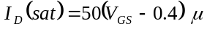A
_______________________________________

TYU 11.3
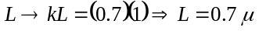m
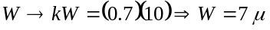m
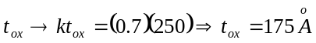
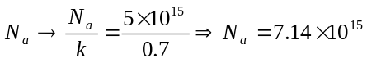cm
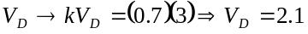V
_______________________________________

TYU 11.4
We have from Example 11.6,
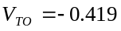V, 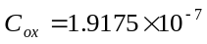F/cm
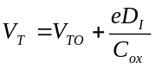
- 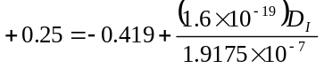
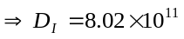cm
- 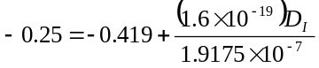
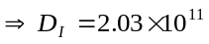cm
_______________________________________

